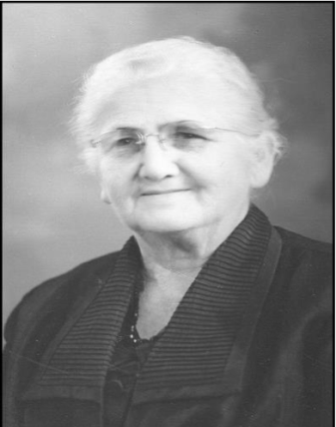
ANNIE RHODES MEMORIAL SCHOLARSHIP APPLICATION
Annie Elana Rhodes (1892-1973)
Ms. Rhodes was born August 9, 1892 in Fort Deposit, Alabama. Her life was one of commitment to the Women’s Missionary Union because of her love for missions. This love brought about a desire in her to see other women learn to pray and give to missions. She endeavored to encourage others to action by serving as W.M.U. District Vice-President. She also served in the Baldwin Association as W.M.U. President, Vice-President, “Community Missions” Chairman, and Prayer Chairman. Following her death in 1973, the Annie Rhodes Memorial Scholarship was established in 1975 in honor of her Christ- like love and service to others.
Application for scholarship must be received by May 1, 2021
Mail application to:
Annie Rhodes Memorial Scholarship Chairperson
Baldwin Baptist Association
P.O. Box 459
Silverhill, AL 36576

Checklist for Complete Application:
  - 􏰀 A young woman admitted to University of Mobile or Judson College
  - 􏰀 Active member of a Baldwin Baptist Church, Cooperating with the Baldwin Baptist Association
- 􏰀 A letter of recommendation, written by someone in church leadership
- A typed personal testimony, including your salvation experience and how God is working in your life.
- 􏰀 A typed essay that answers each of these topics. Please format your essay with these headings:
o Goals (What are your future goals and why?)
o Involvement (Describe your involvement with your church and/or mission activities.)
o Extracurricular (Discuss any school/community activities you are involved in.)
􏰀 A copy of your latest high school or college transcript.
􏰀 A completed application including picture
*An interview may be conducted with each qualified applicant. Consideration may be given to a prospective recipient entering Christian service.
Date:_________
Application Approved:_____
Not Approved:____
Amount:______
Attach Student’s Picture Here

ANNIE RHODES MEMORIAL SCHOLARSHIP APPLICATION
BALDWIN BAPTIST ASSOCIATION
15840 State Highway 104
P.O. Box 459
Silverhill, AL 36576
(251) 945-5112

Name of applicant:_____________________________________________________________________
Phone: _____________________ Email Address:_____________________________________________
Address:_____________________________________________________________________________
City: _______________________________________ State: _______________ Zip: ________________

Name of parents or guardian:_____________________________________________________________
Address:_____________________________________________________________________________
City: _______________________________________ State: _______________ Zip: ________________

Name of church where you are a member: __________________________________________________
Name of college where you (will) attend:___________________________________________________
Year in college: _________________________ Anticipated year of college graduation: _______
ACT/SAT score or GPA last term: ____________________________________
Current employment: __________________________________________________________________
Statement of Integrity:
In accepting a scholarship from the Women’s Missionary Union, I fully understand that I shall be expected to adhere to the New Testament principles as taught and believed by the Southern Baptist faith and doctrine. I further pledge to be a faithful Christian and live an exemplary life.
Signature: ________________________________________________ Date: _______

